Module 8 Portfolio Project

Kyle Parrish
Colorado State University Global
Course Code: CSC372-2
Nizar Dajani
5/11/2025

Application Screenshots

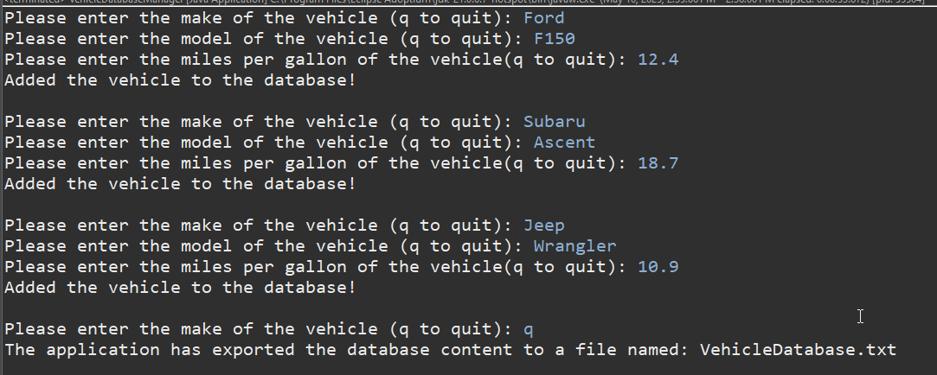

Application Output
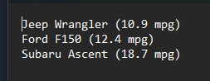

Git Repository
